<>cmeprojects
System admin manual
Every setting, people and access, compliance, website, reports and routine checks
Engaged Care Melbourne · Staff Portal
Version 1.1 · November 2026
Prepared by cmeprojects

Contents

Right-click the list and choose Update field if the page numbers don't show.

About this manual
This manual is for the system admin and the managers who look after parts of the portal. It covers every setting, how people and access work, and what to check each day, week and month. For setting the portal up from nothing, see the Setup guide.

Access levels
Access level | What it can do
New starter | Onboarding only, until they're given a role.
Support worker | Sees only tasks they're assigned to, helping on or created. Can be in several teams.
Team leader | Leads one team, and also sees the tasks of everyone in it.
Manager | In the core team: every team's tasks, approvals, reports and due dates. Invites people, changes roles and teams, adds job titles.
Staff admin | In the core team, like HR: invites people and manages their details. Role and team changes go to a manager to approve. Doesn't see other people's tasks.
System admin | Everything, plus System settings. The only role that can create system admins. Hidden from other staff and never given tasks.
Every job title (for example Disability Support Worker) is linked to one access level. The database enforces each level, so a person can never see more than their level allows, even through a link.

Where everything is
Menu | Who sees it | What it's for
Dashboard, Tasks | Everyone | Daily work, task lists and registers
Tools | Managers | Built features, Cars and phone apps in one place
Forms | People who can make forms | Make, send and report on forms
Enquiries | Chosen roles | Website enquiries and call-backs
People | Managers, staff admins | Staff, Teams, Roles, Clients, Compliance
Reports | Chosen roles (premium) | Task, car, compliance and feature reports
Settings | System admin, delegated managers | Due dates, System settings, Features, Website settings, Change log, Feature builder, System health

Your routine
How often | Check
Daily | The dashboard: escalated and overdue tasks, approvals, new enquiries
Weekly | Compliance: uploads to review, documents expiring in the next 30 days; the cars weekly report
Monthly | System health; the Assistant's spending against its limit; the change log for unexpected changes
Each year | Add next year's public holidays (and the Grand Final Friday); review roles, teams and who can see reports
When someone leaves | Deactivate them on the Staff page the same day

Settings: save, then deploy
Every change in Settings is saved first, then deployed. Saving keeps it as a draft: staff see nothing different. Deploy makes all saved changes live together.
- Save is greyed out until you change something, and again after a successful save. A green ✓ Saved. Not live yet confirms it.
- Anything saved but not live shows a yellow Not live yet label.
- While there are saved changes, a yellow bar shows on every page. Press Review and deploy to see the list, then Deploy or Discard.
- You're reminded with a pop-up after signing in and when you leave Settings.
- Managers and staff admins you've delegated to deploy their own changes; you can deploy everyone's.
- Straight away, without Deploy: uploading website documents, Demo data, signing people out, and built-feature switches.

System settings
Open Settings → System settings. The tabs: Features, Notifications, Delegation, General and Demo data. Website settings has its own tab in the Settings menu and is always open to you, even while the website is off.

Features
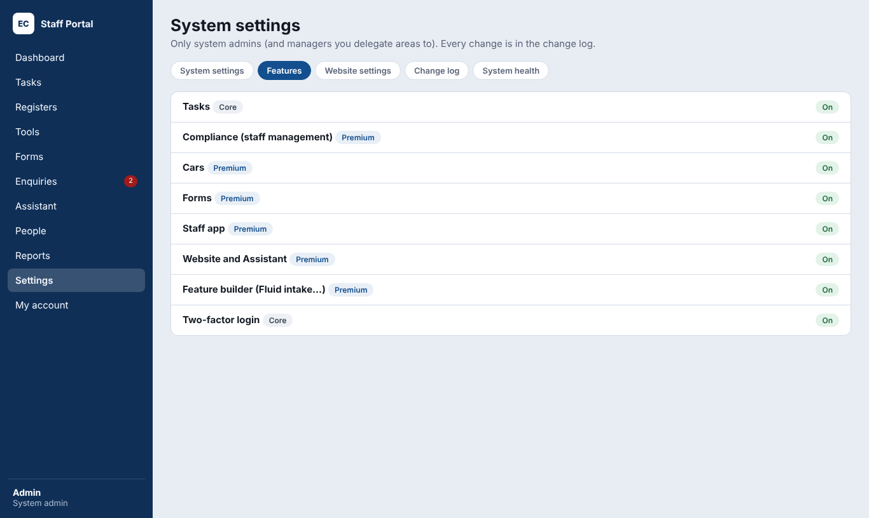
Features.
One row per feature. Open a row (one at a time) to see its main switch, its parts, who looks after it, and its settings. Switching something off hides it and blocks it; its records are kept. You can still use and change anything that's off, so others rely on you for it.
Row | What you can switch | Notes
Tasks and registers | Always on; parts: auto-escalation, attachments | Task settings; who adds registers
People, clients and scoreboard | Always on; parts: Teams, Roles (job titles) | Teams off: team leaders work like support workers. Roles off: access levels only; job titles are kept.
Compliance and onboarding | Main switch; parts: read and confirm, trainings, uploads, forms in onboarding | My onboarding shows only while a part is on. A part that's off never holds up onboarding.
Forms | Main switch; part: Form builder | Builder off: only you make or change forms; published forms still work.
Cars and Cars app | Main switch | Car settings and the app icon
Staff app | Main switch | Name, icon and contents
Website, Assistant and enquiries | Main switch | Off: the sign-in page is the front page and enquiries stop
Reports and exports | Main switch | Each report follows its feature
Sign-in | Two-factor login, sign-in link, Google sign-in | Which roles need two-factor
Built features | Each built feature | Only you build them
Packages at the top (Essentials, Recommended, Everything) set the main switches in one press, to match a budget. Then deploy.
Looked after by: … · Change on a row opens a pop-up to choose who looks after that area (see Delegation).

Notifications
Every notification, grouped by feature (open one group at a time). Tick Bell and Email for each. Groups for features that are off aren't shown: nothing is sent for them. The Emails switch at the top turns every email on or off.

Delegation
For each area, choose who looks after it besides you: Only me, All managers, or Selected people (managers and/or staff admins).
Area | What they can change
Adding registers | Make new registers and set them up
Roles | Add and change job titles
Branding | Name, logos, colours and wording
Messages | Support contact, announcement and invite note
People rules | Approvals, invites and new starter settings
Compliance settings | Who manages compliance and expiry warnings
Task settings | Due dates, reminders, escalation, holidays
Who can see Reports | Report access by role
Car settings | Everything on the Cars row
Website | Where the Assistant looks, its documents and the About page
Read the change log | See every settings change
Security, Features, Notifications, Demo data and General always stay with you.

General
- Branding: name and logo, colours, wording.
- Messages to staff: support contact, announcement, invite note.
- Signing out: minutes of no use before people are signed out, and Sign everyone out (type SIGN OUT).
- Region and Records.

People

Inviting someone
- Open People → Staff. Under Invite someone, type their full name and email (any email works; no Microsoft account needed).
- Press Send invite. They get a branded welcome email and start as a new starter.
- If they don't receive it, open their row and press Resend invite.

Changing a person
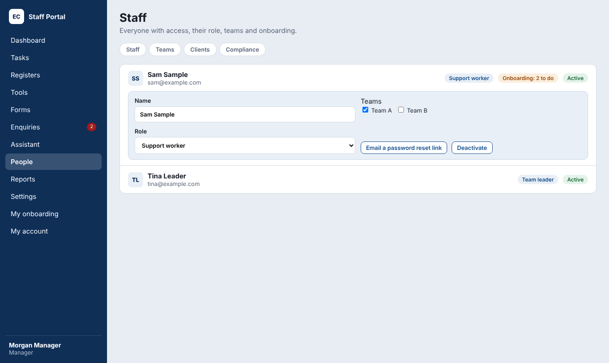
Staff: open one person at a time.
- Open People → Staff and press Edit on their row. Only one person opens at a time.
- Change their name, role (job title) and teams as needed.
- Press Save changes once. The message says what was saved, or what was sent for approval.
- A new role takes effect straight away, even if they're signed in.
- You can't change your own role. The only active manager can't be changed until there's another manager.
- Role changes made by staff admins appear at the top of the page for a manager to Approve or Decline.

New starters and conditional roles
A new starter's row shows how much of their onboarding is left. When it's done, give them a role. If they need to start work first, use Give conditional role: choose the role, a deadline and the reason. They get a Finish onboarding task due on the deadline.

Helping someone sign in
Button | When to use it
Email a password reset link | They've forgotten their password
Reset two-factor login | They've lost or changed their phone
Clear Cars app PIN | They've forgotten their app PIN
Sign out of all devices | System admin only. A lost phone or a shared login: signs them out everywhere within a minute. Their account stays active.
Deactivate | They've left. They're signed out straight away; their tasks and history stay.
Reactivate | They've come back

Teams, roles and clients
- Teams: add a team, its members and its team leader. Managers and staff admins are in the core team and don't need one.
- Roles: add job titles and link each to an access level. Managers can add titles; only the system admin creates system admins.
- Clients: the client list used on tasks and car trips.

Compliance
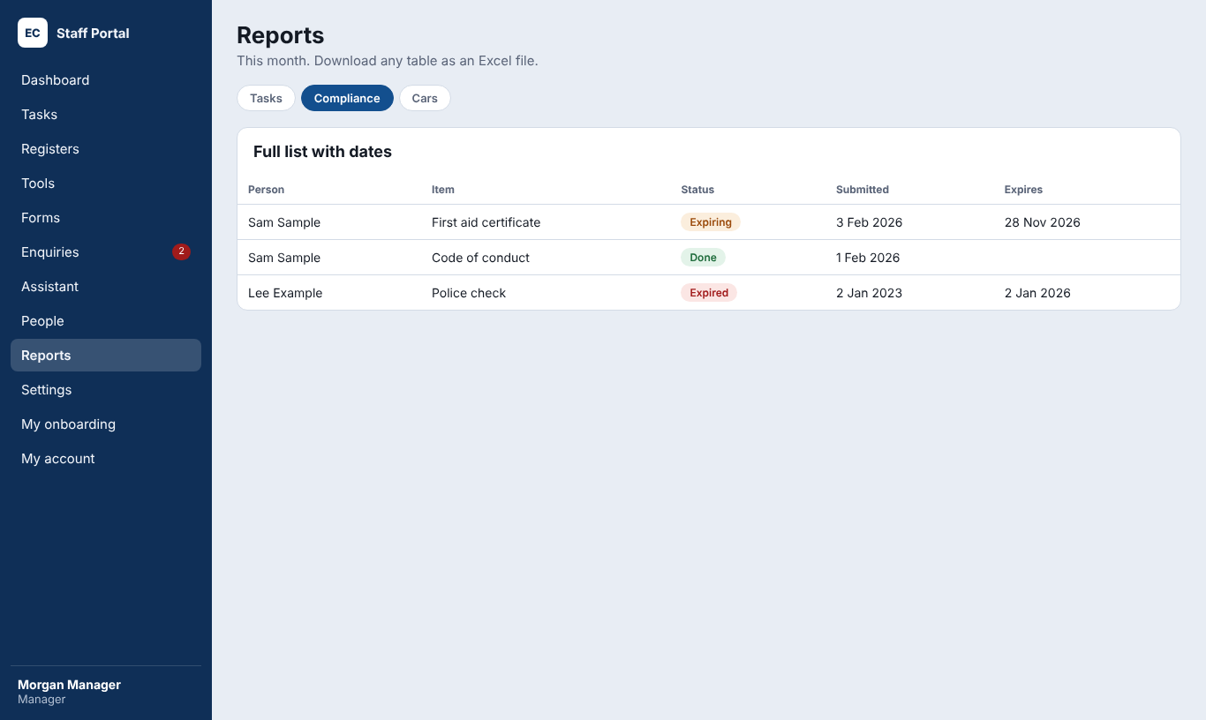
The compliance report.

Compliance items
- Open People → Compliance and press Add item.
- Choose the type: Read and confirm, Training, Upload or Form.
- Add the title, the document or instructions, and whether it expires (and how often it's renewed).
- Choose the roles and the teams it applies to. The form shows how many people it will reach.
- Save. It appears in each matching person's My onboarding straight away.
Most common question
An item reaches people who match a chosen role and a chosen team. If someone can't see a training, check both.

Reviewing uploads
Uploads waiting for review are listed on the Compliance page. Open one, check the document and expiry date, then Accept or Send back with a reason. You can also upload a document on someone's behalf from their person page.

Expiry
People are warned before a document expires (the number of days is in System settings → People → Compliance). Expired documents show in red on the Staff page and in the compliance report.

Tasks, due dates and registers

Due dates (SLA)
Managers open Settings → Due dates (SLA) to set how many business days each priority gets, when reminders are sent and when overdue tasks escalate.

Setting up a register
- Open Tasks → Registers and press New register (or Setup on an existing one).
- Add fields: text, number, date, choice list, yes/no, person or client. Mark the required ones and drag them into order.
- Choose whether records need a manager's approval before they're completed, and who manages the register.
- Add follow-up actions people can choose after a record, such as Review the risk plan.

Approvals and escalation
Tasks that need approval wait in Awaiting approval until a manager approves them. Overdue tasks escalate automatically to the team leader, then the managers. Managers get a daily summary email if it's switched on.

Enquiries
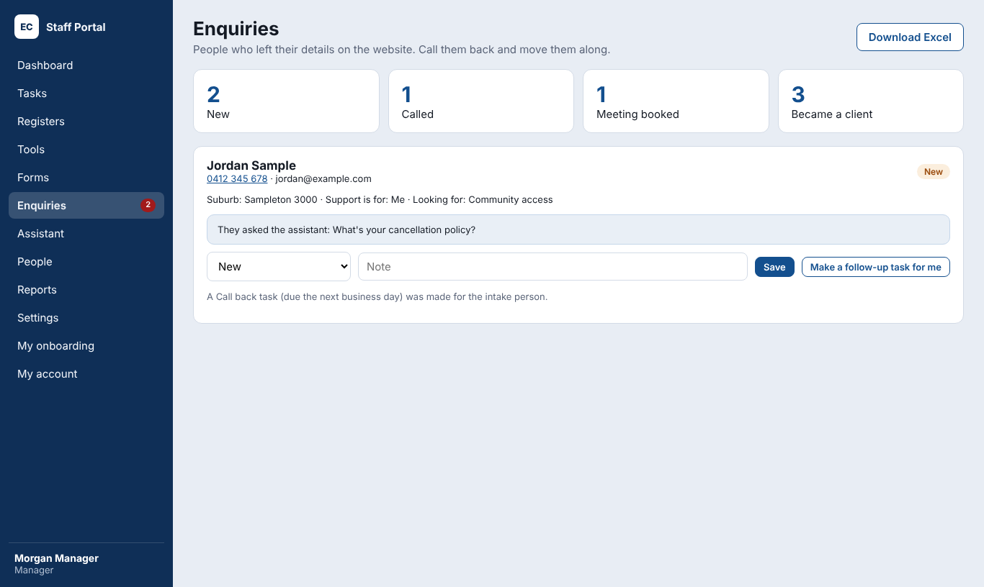
Enquiries.
Each Request a call back from the website becomes an enquiry and a Call back task for the intake person, due the next business day (weekends and public holidays don't count). The intake person also gets a bell notice (and an email once emails are set up).
- Move each enquiry through New, Called, Meeting booked, Became a client or Not going ahead.
- Who sees enquiries and who calls back are set in Website settings → Enquiries (staff admins to start with).

Website settings
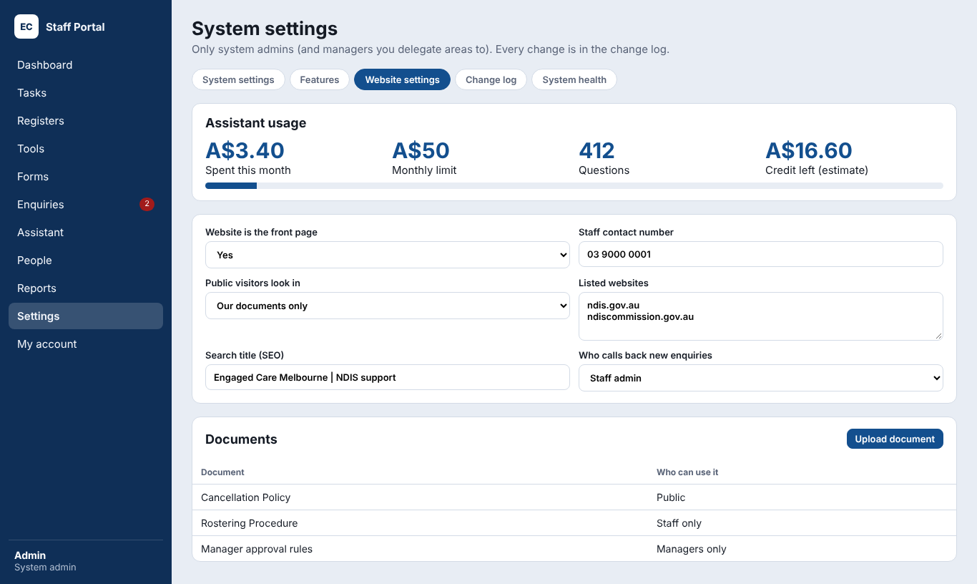
Website settings: usage, settings and documents.
Open Settings → Website settings. Each part saves on its own and shows ✓ Saved.
Part | What you set
Website | Logo, whether the website is the front page, staff contact number, the words shown while it's off
Landing page | Heading, the line under it, suggested questions, urgent support number
Where it looks for answers | Documents, listed websites or both, for visitors and staff; the listed websites; what it says when it can't answer
Documents | Upload Word, text or PDF (scanned PDFs are read by the AI). Choose who can use each: Public, Staff only or Managers only.
About page | Who we are, mission, vision and services (a delegated manager can edit these)
Search engines (SEO) | Website address, the title and description Google shows
Enquiries | Who sees enquiries; who calls back new ones
Model, limits and credit | Haiku (lower cost) or Sonnet; monthly spending limit; questions per hour; credit bought
- Test the AI: press Test the AI connection after adding or changing the AI key.
- Keep documents current: replace a policy when it changes, so the Assistant answers from the new version.
- Watch spending at the top of the page, or in System health.

Reports and exports
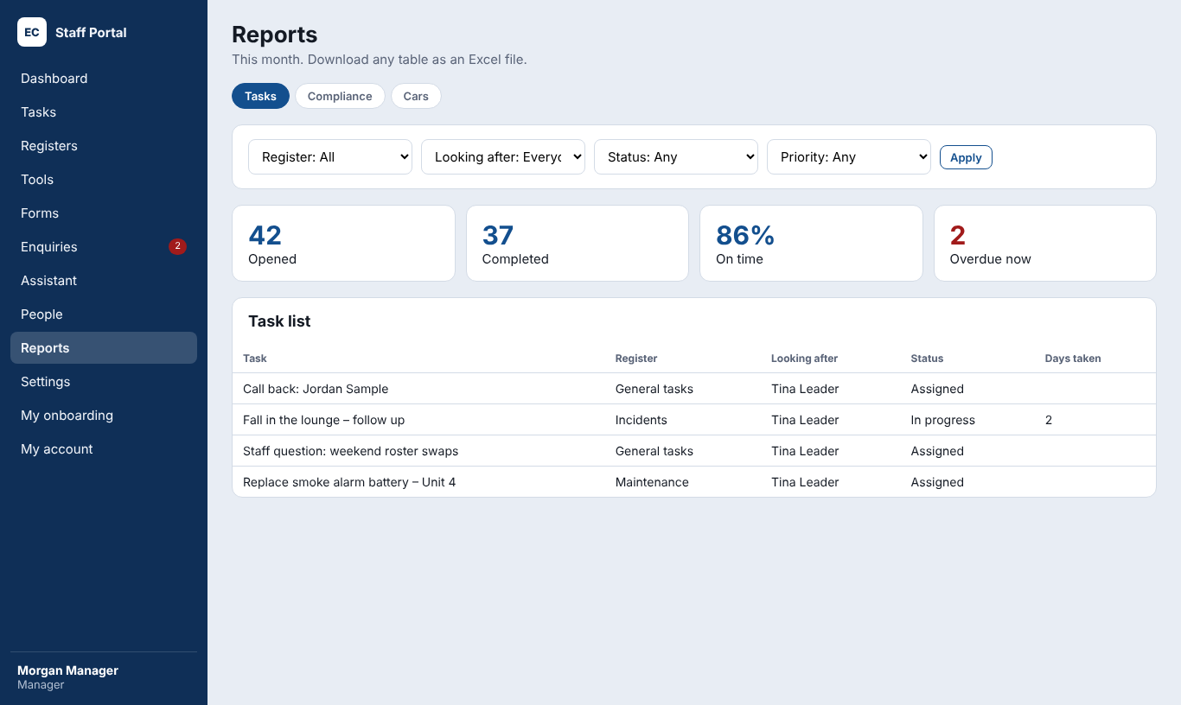
Task reports.
- Tasks: filter by register, person, team, status, priority and dates. Download Excel with your logo and the date range.
- Cars: trips, kilometres and cars by person and client.
- Compliance: every person and item, with submitted and expiry dates.
- Built features: a report for each Feature builder feature.
Reports and exports is a premium module. Who sees each report is set in System settings → Reports.

Forms
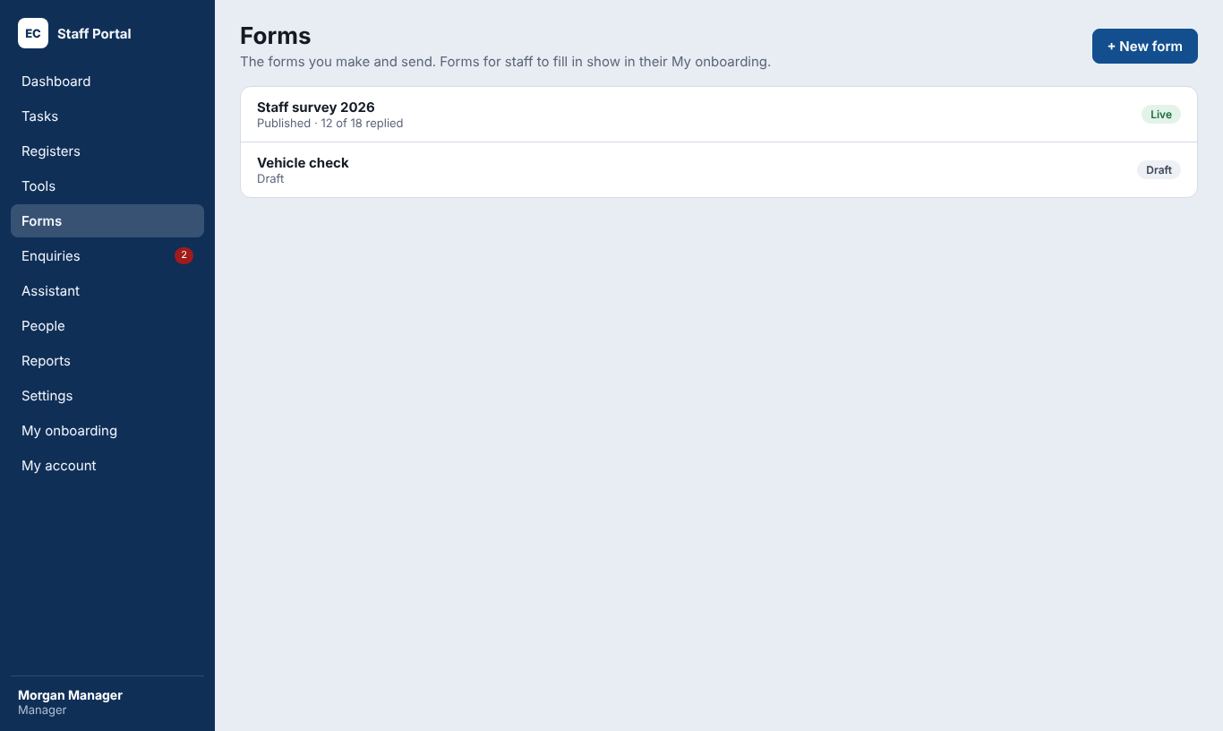
Forms.
- Open Forms and press New form. Add questions: short answer, paragraph, choice, checkboxes, date, number, yes/no or file.
- Press Try it to see the form as staff will.
- Press Publish. Then Send it to people, a team or everyone, with a due date.
- Press Remind to nudge people who haven't answered.
- Use Put in Compliance to make it part of onboarding for chosen roles and teams.
- See answers under Replies and download Excel. Print a QR sticker for forms filled in on the spot.
Each form is controlled by the person who made it and anyone they Share it with. Copy makes a new draft from it; Delete removes a form with no replies.

Feature builder
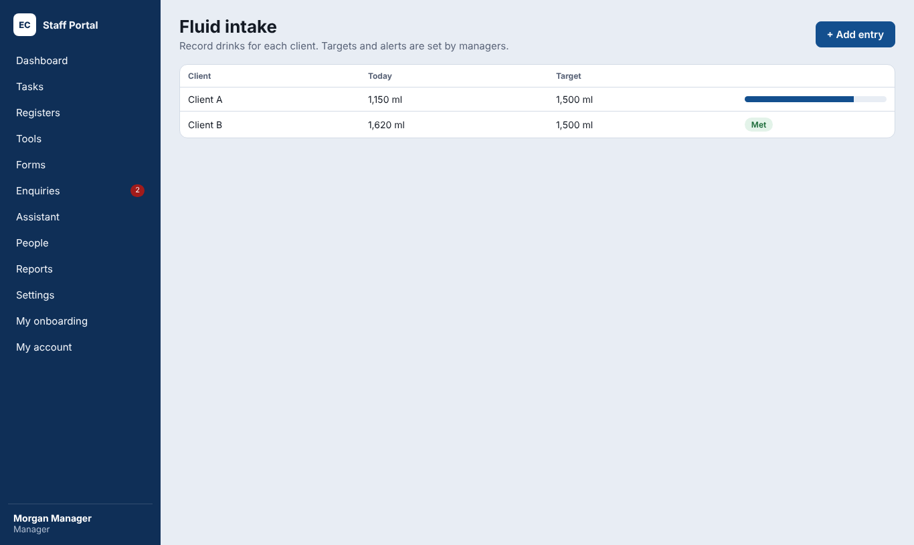
A built feature with targets.
Build simple features without code, such as a fluid intake chart, a medication check or a petty cash log.
- Open Settings → Feature builder and press New feature.
- Add the fields, choose an icon and colour, and watch the live preview.
- Choose who can fill it in and who sees its report.
- Press Publish. It appears in Tools and, if chosen, in the Staff app.
Drafts you don't need can be deleted. Each published feature is a premium add-on.

Cars
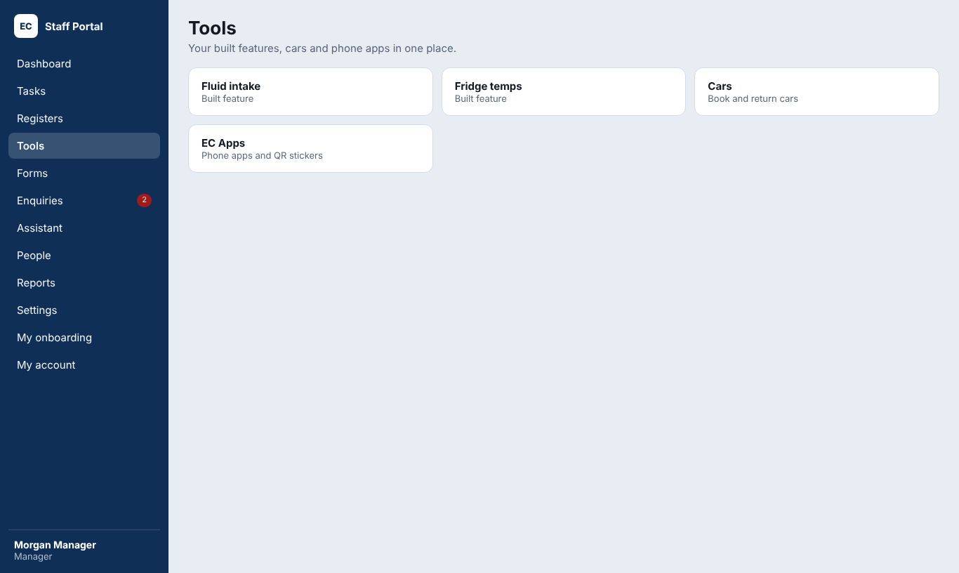
Tools.
- Manage cars: add each car with its registration and odometer; mark one out of service.
- Purposes and clients: the choices people pick when starting a trip. Hide ones no longer used.
- Correct a trip or return for someone when a mistake is made.
- The weekly report is emailed to the people chosen in System settings → Cars.

Change log, System health and Demo data
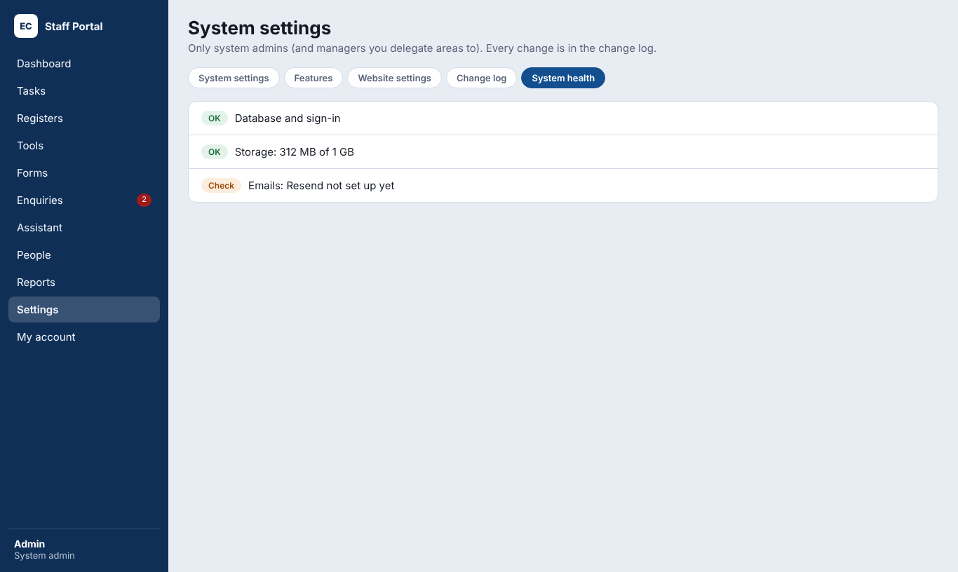
System health.
- Change log: every settings change, with who made it and when.
- System health: checks the database, file storage, emails, the hourly timer and the Assistant's spending. Everything should say OK.
- Demo data (System settings → Demo data): Load sample records for training or a demo, then Delete sample records to remove only those. Delete every task removes every task and starts fresh; use it only before go-live.

Security and privacy
- Data is stored in Sydney (Supabase) and served from Sydney (Vercel).
- Every table is protected by the database itself: a person can only read what their role allows.
- Two-factor login for chosen roles; 5 wrong passwords lock an account for 15 minutes; idle sign-out.
- Daily backups on Supabase Pro.
- Never share keys, passwords or codes by email or chat. Keep them in a password manager.
- Deactivate people the day they leave.

Troubleshooting
Problem | Check
Someone can't see a training | The item's roles and teams both include them
Emails aren't arriving | System health → Emails; the Resend key and domain in Vercel
The Assistant doesn't answer | Website settings → Test the AI connection; the monthly limit; the AI credit
People are signed out often | System settings → Security → Signing out; the Supabase session settings
Due dates look wrong | Public holidays and Weekdays only in System settings → Tasks
A menu is missing | The feature is on in Features, and the person's role is allowed
The footer number is missing | Website settings → Website (staff number) and Landing page (urgent number)

Quick answers
I want to… | Go to
Change the logo or colours | Settings → System settings → Branding
Turn a module on or off | Settings → System settings → Features, then Deploy
Let managers or staff admins look after an area | Settings → System settings → Delegation, then Deploy
Add a public holiday | Features → Tasks and registers → Task settings
Choose bell or email for a notification | Settings → System settings → Notifications
Change due dates | Settings → Due dates (SLA)
Change who calls back enquiries | Settings → Website settings → Enquiries
See what the AI has cost | Settings → System health, or Website settings
Load or clear demo records | Settings → System settings → Demo data
Undo a big change | Ask cmeprojects: every change has a restore point

